$mango

Creating Database
>use sohan

Insertion
> db.sohan.insertOne(
... {
... "name": "sohan",
... "dept": "ISE"
... }
... )

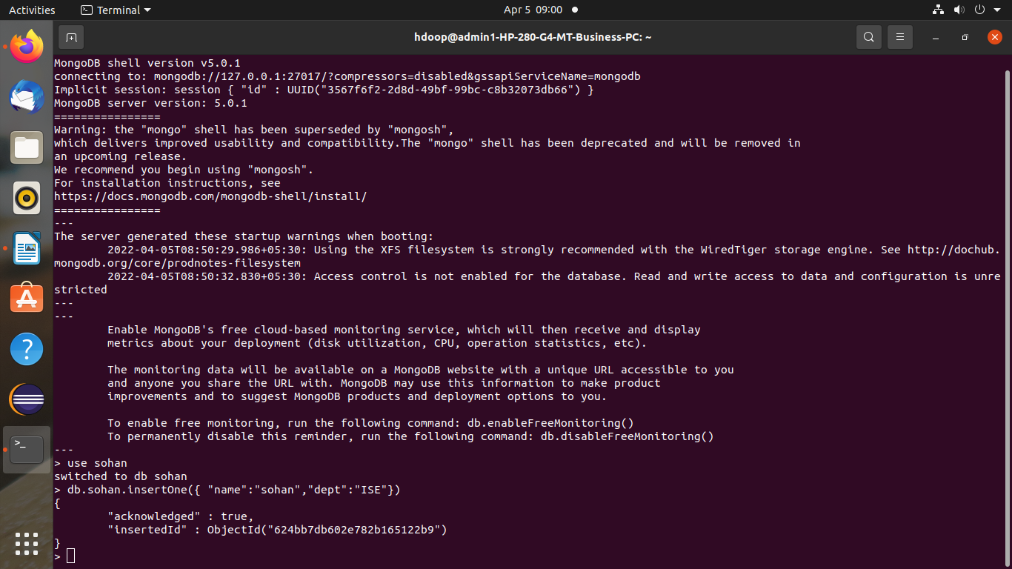

Counting
> db.madhu.count()
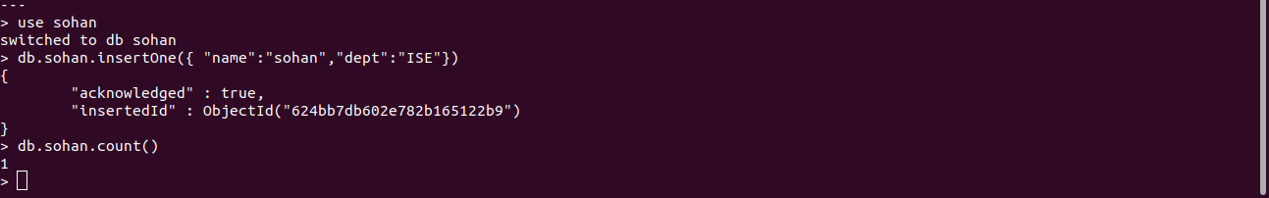

INSERT MANY

> db.sohan.insertMany(
... [
... {"name": "Praneeth" , "dept":"ISE" },
... {"name" : "Prateek" , "dept" : "CSE"},
.. {"name": "Rajesh" , "dept":"ISE" },
...... )

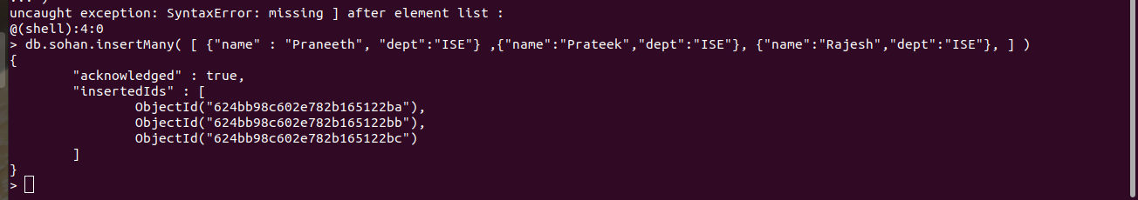
> db.sohan.find()
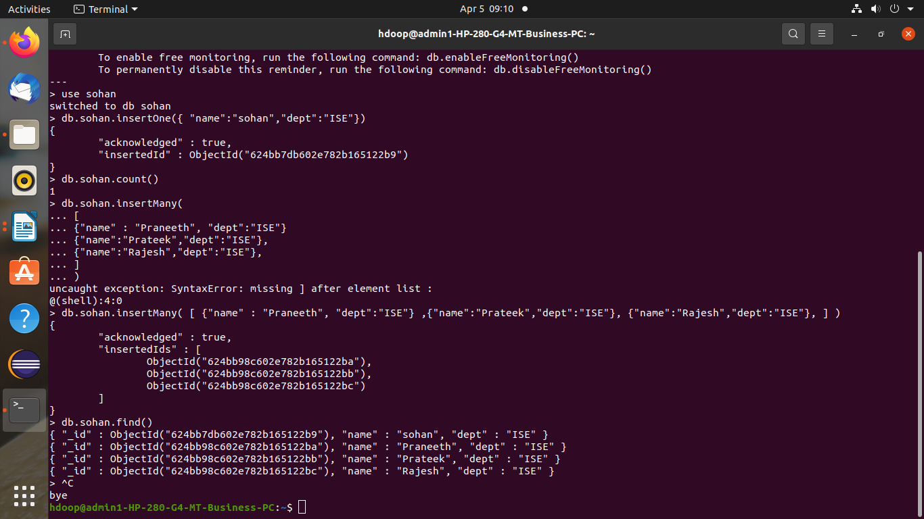

> db.sohan.find().pretty()

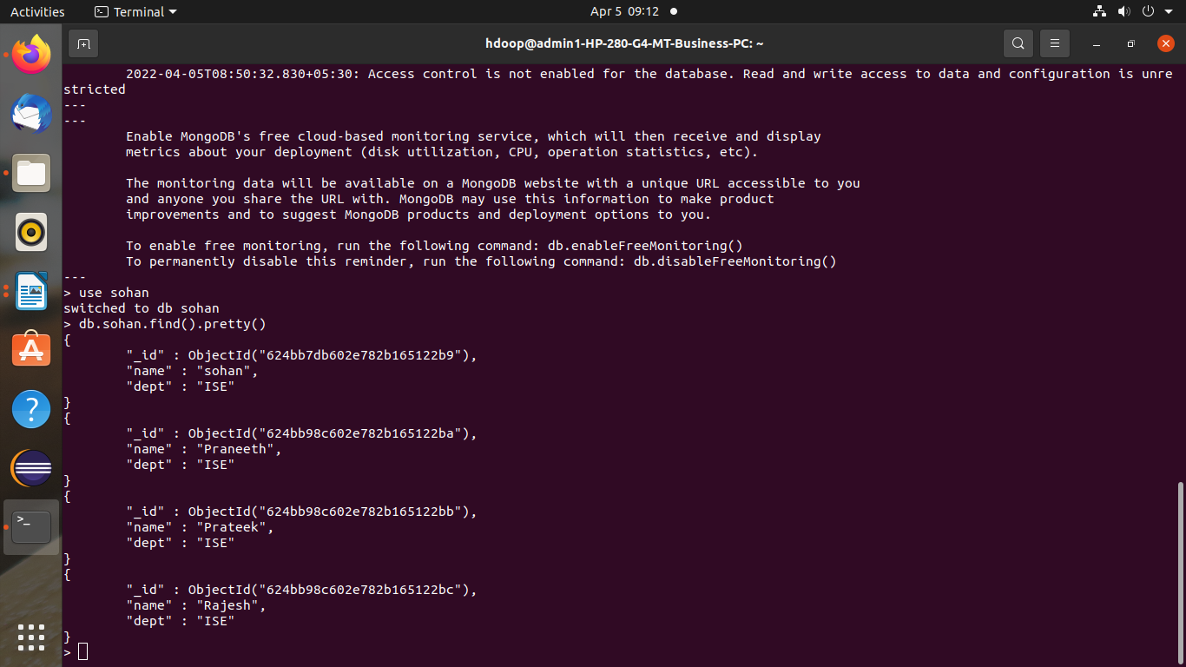

UPDATE

> db.sohan.updateMany

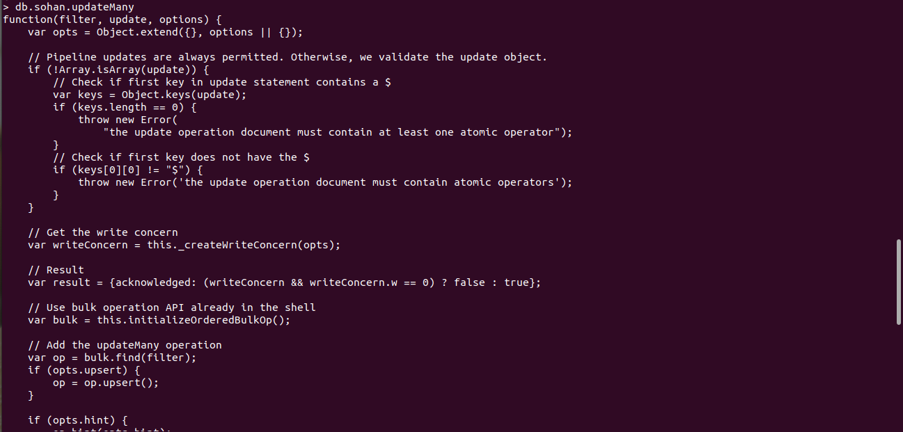

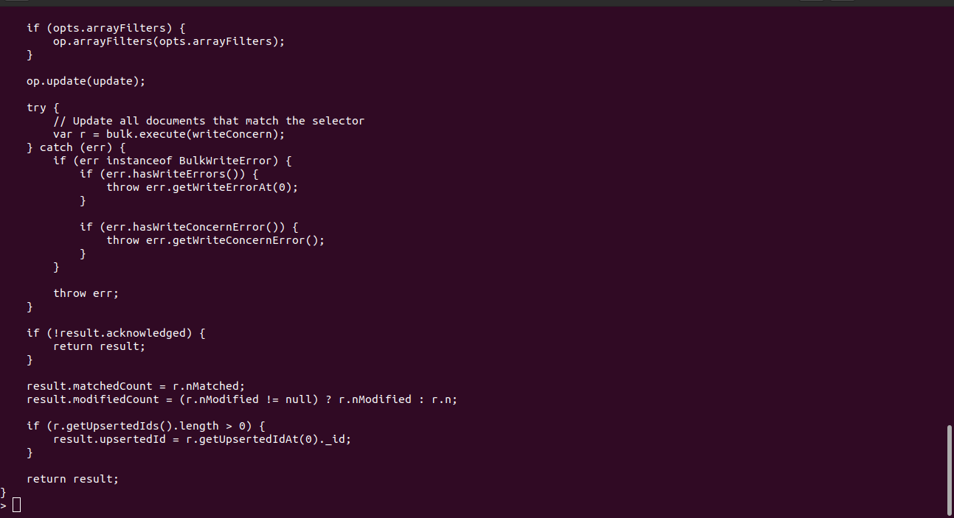

> db.sohan.updateOne(
... {"name" : "Rajesh”},
... {
... $set : {"dept":"CSE"}
... }
... )

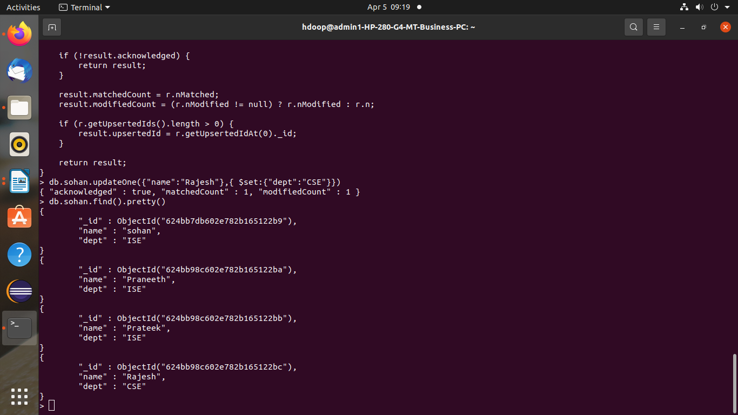

> db.sohan.deleteOne({"name":"Praneeth"})

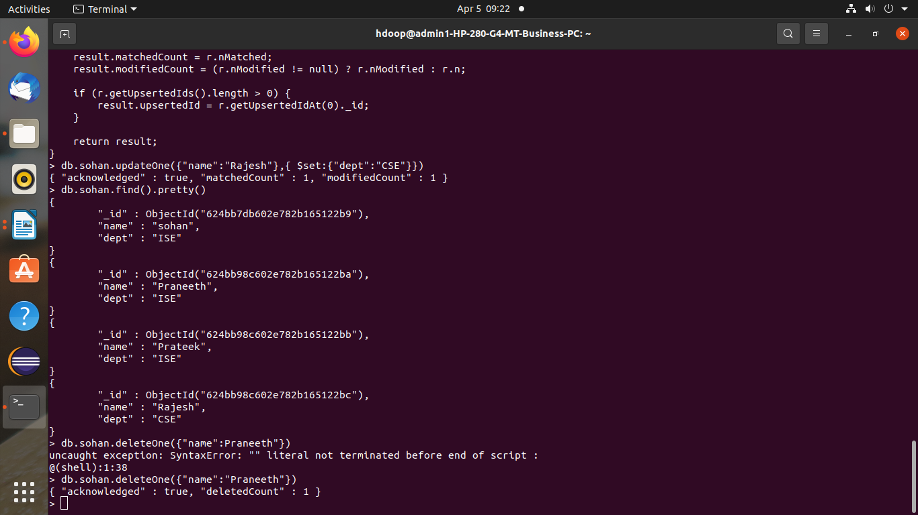
> db.sohan.updateOne(
... {"name" : "madhu"},
... { $unset : { "dept" : ""}})

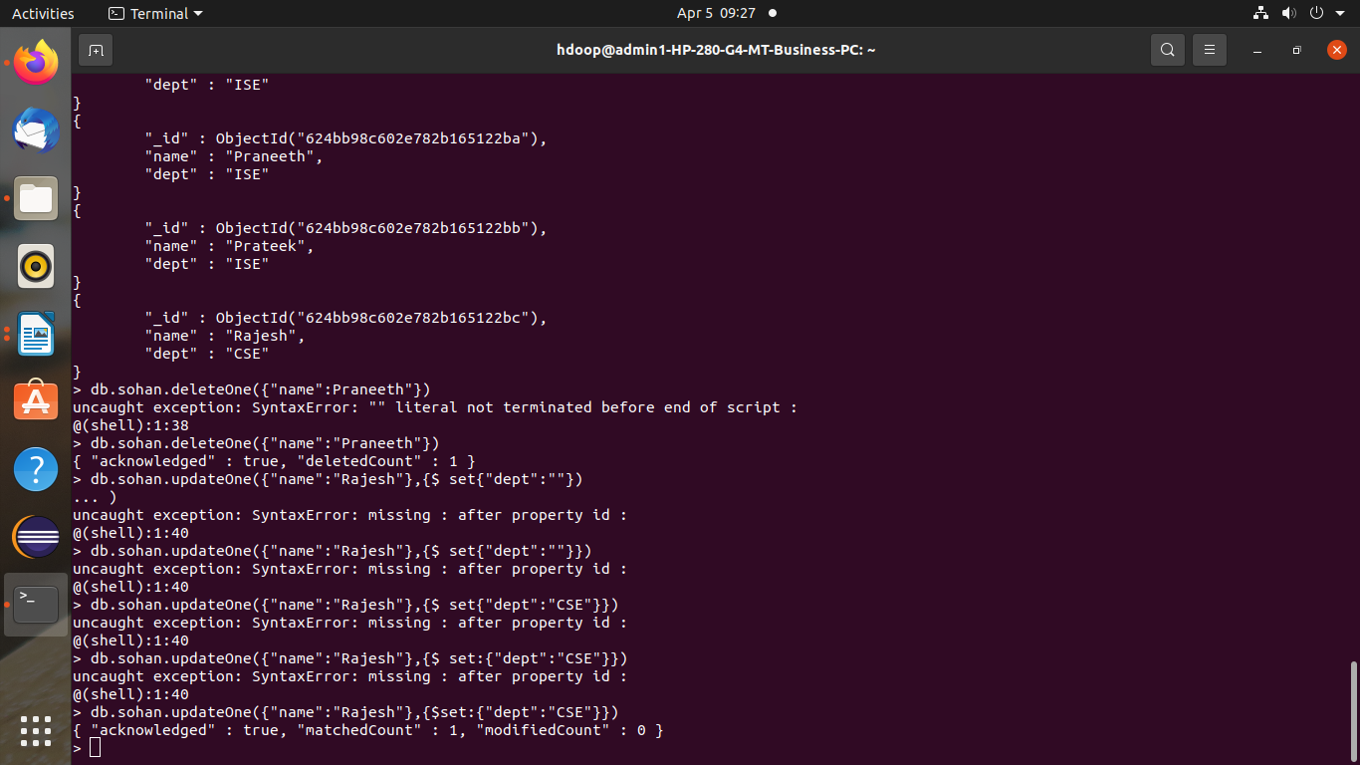
> db.sohan.deleteMany({"dept":"ISE"})

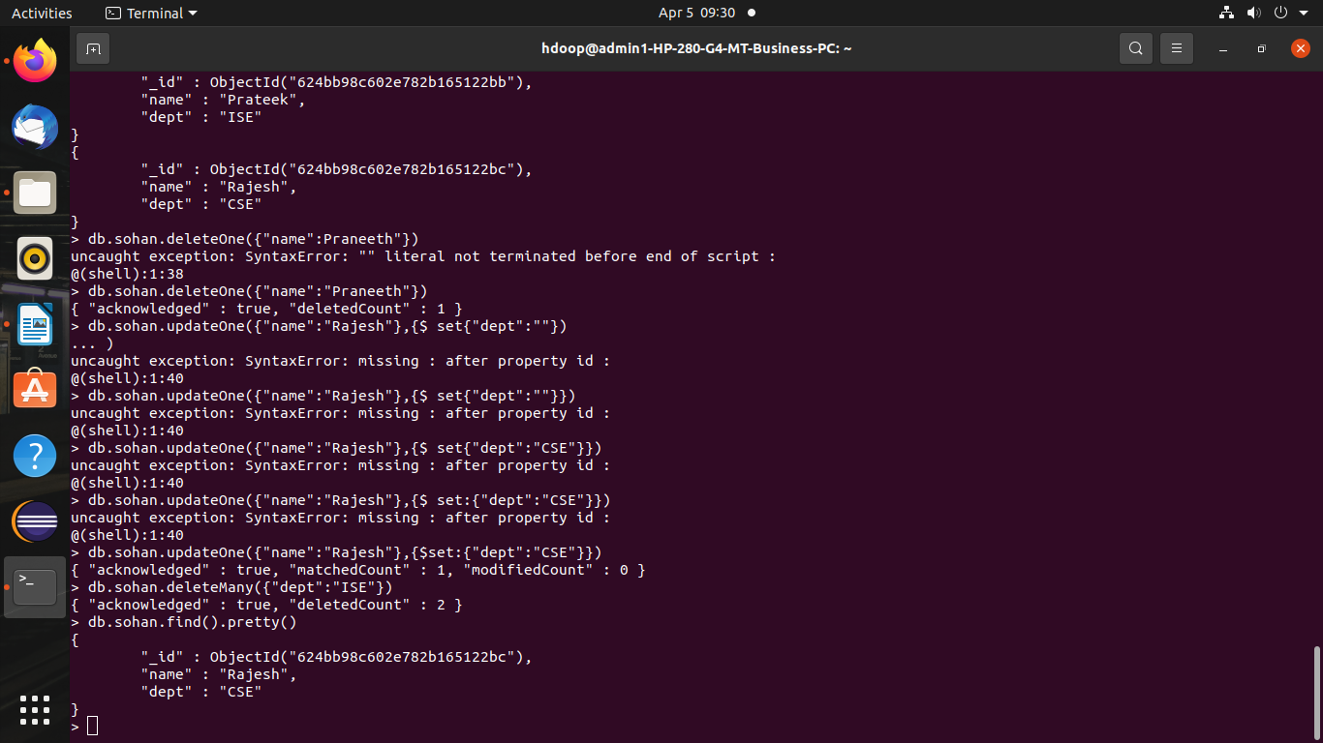
REPLACE

db.sohan.replaceOne(
... {"name":"Madhu"},{"name":"Vinayak","dept":"ISE"})

